Practical no:-2
3263
Q.write a program to display “welcome” message using java script.
1.installation:-
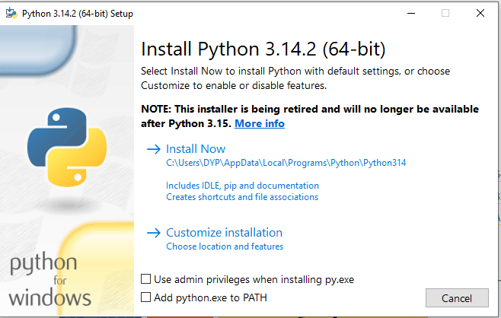
2.progrm run:-

